Homework 3 – NumPy

# Task 1

In this exercise, you’ll be practicing matrix and vector computations using NumPy. You should **not** use any loops in your code.

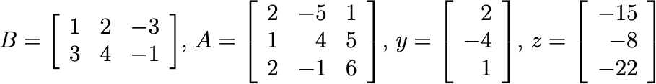Create numpy arrays representing each of the following:

Provide numpy code that calculates and prints each of the quantities below.

* + *BA* (matrix dot product)
  + *ABT* (matrix dot product)
  + *Ay* (element-wise product)
  + *yTz* (dot product)
  + *yzT* (dot product)

# Task 2

In this exercise, you’ll be practicing data analysis using NumPy.

Among the many data sets used in climate change research, the Sea Ice Index, or the area covered by sea ice in the northern hemisphere shows particularly marked changes. There are seasonal variations across each year, and trends that span a number of years.

The file sea_ice.txt (posted on Canvas) contains northern hemisphere total sea ice data, in units of millions of square km, between 1979 and 2013 (i.e., 35 years in total). There are 24 measurements per year, measured once every half a month. The data in sea_ice.txt has 35 rows (one row per year) and 25 columns where the first column contains the year in which the measurements in that row were taken; the half-monthly measurements are stored from the second to the last column.

Load the file sea_ice.txt into a numpy array using loadtxt() function, then write numpy code to solve the following problems. You should **not** use any loops in your code.

1. Determine the annual average sea ice extent, i.e. for each year, compute the average of all the half-monthly measurements over that year.
2. Determine the average sea ice extent for each half-month, i.e. average over the years for each half-month.
3. Determine the average sea ice extent over the entire data collection.
4. For each year, determine the number of half-months that exceeds the overall average calculated in Question 3.
5. Determine the number of years whose annual average is less than the overall average calculated in Question 3.
6. Determine the number of years, within the last 10 years of data, whose annual average is less than the overall average calculated in Question 3.
7. Determine the 10 years that have the lowest 10 annual average sea ice extents. You should arrange the 10 years such that their corresponding annual averages are sorted in ascending order. That is, the first year in the list is the year that has the lowest annual average sea ice extent, the second year has the second lowest annual average and so on.
8. The original data set contains half-monthly data, but you want to work with monthly data. You want to obtain a 2-dimensional array which contains monthly data. The matrix should have 35 rows and 12 columns. Column 1 contains the average of the two measurements in January, Column 2 for February, etc.

# Submission

**Use comments or markdown in Jupyter Notebook to clearly indicate which code is for which question.**